

AP® Physics C
1987 Free Response Questions

The materials included in these files are intended for use by AP teachers for course and exam preparation in the classroom; permission for any other use must be sought from the Advanced Placement Program®. Teachers may reproduce them, in whole or in part, in limited quantities, for face-to-face teaching purposes but may not mass distribute the materials, electronically or otherwise. These materials and any copies made of them may not be resold, and the copyright notices must be retained as they appear here. This permission does not apply to any third-party copyrights contained herein.

These materials were produced by Educational Testing Service® (ETS®), which develops and administers the examinations of the Advanced Placement
Program for the College Board. The College Board and Educational Testing Service (ETS) are dedicated to the principle of equal opportunity, and their
programs, services, and employment policies are guided by that principle.

The College Board is a national nonprofit membership association dedicated to preparing, inspiring, and connecting students to college and opportunity.
Founded in 1900, the association is composed of more than 4,200 schools, colleges, universities, and other educational organizations. Each year, the
College Board serves over three million students and their parents, 22,000 high schools, and 3,500 colleges, through major programs and services in
college admission, guidance, assessment, financial aid, enrollment, and teaching and learning. Among its best-known programs are the SAT®, the
PSAT/NMSQT®, and the Advanced Placement Program® (AP®). The College Board is committed to the principles of equity and
excellence, and that commitment is embodied in all of its programs, services, activities, and concerns.

APIEL is a trademark owned by the College Entrance Examination Board. PSAT/NMSQT is a registered trademark jointly owned by the College Entrance Examination Board and the National Merit Scholarship Corporation. Educational Testing Service and ETS are registered trademarks of Educational Testing Service.
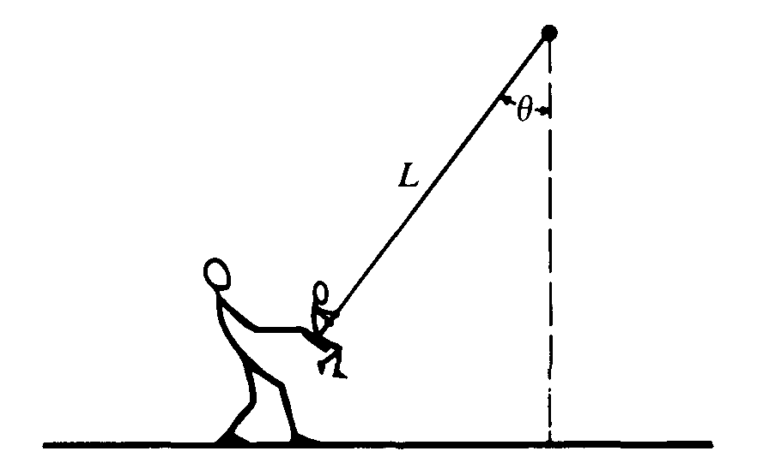
1987M1. An adult exerts a horizontal force on a swing that is suspended by a rope of length L, holding it at an angle θ with the vertical. The child in the swing has a weight W and dimensions that are negligible compared to L. The weights of the rope and of the seat are negligible. In terms of W and θ, determine
a. the tension in the rope;
b. the horizontal force exerted by the adult.
The adult releases the swing from rest. In terms of W and θ determine
c. the tension in the rope just after the release (the swing is instantaneously at rest);
d. the tension in the rope as the swing passes through its lowest point.
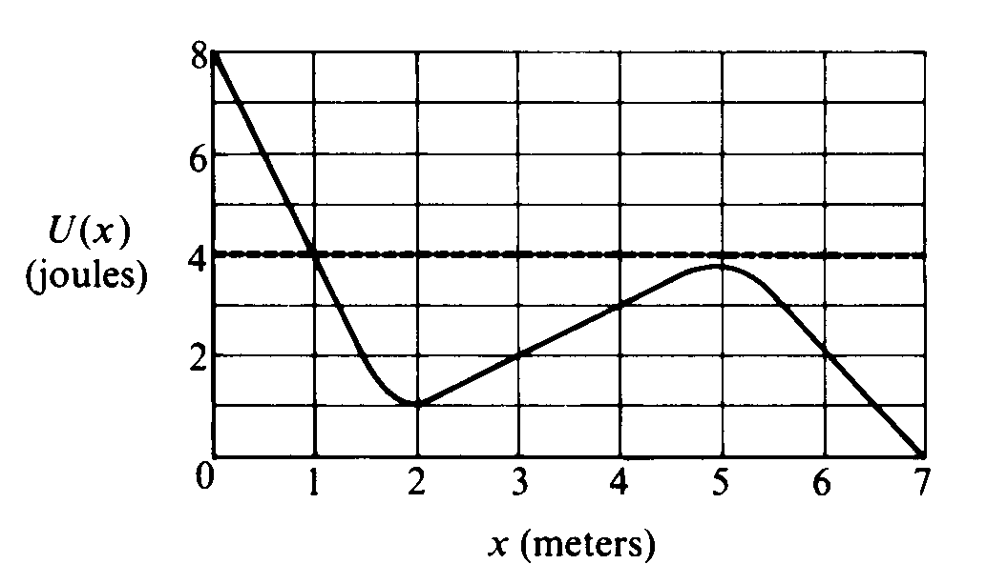
1987M2. The above graph shows the potential energy U(x) of a particle as a function of its position x.
a. Identify all points of equilibrium for this particle.

Suppose the particle has a constant total energy of 4.0 joules, as shown by the dashed line on the graph.
b. Determine the kinetic energy of the particle at the following positions
i. x = 2.0 m
ii. x = 4.0 m
c. Can the particle reach the position x = 0.5 m? Explain.
d. Can the particle reach the position x = 5.0 m? Explain.
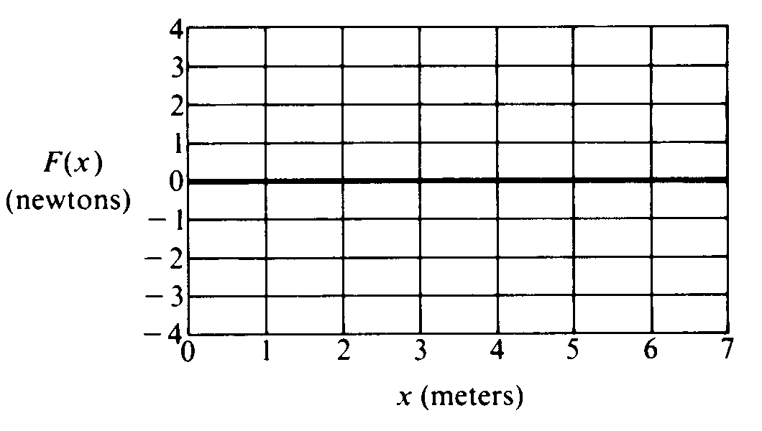
e. On the grid below, carefully draw a graph of the conservative force acting on the particle as a function of x, for 0 < x < 7 meters.

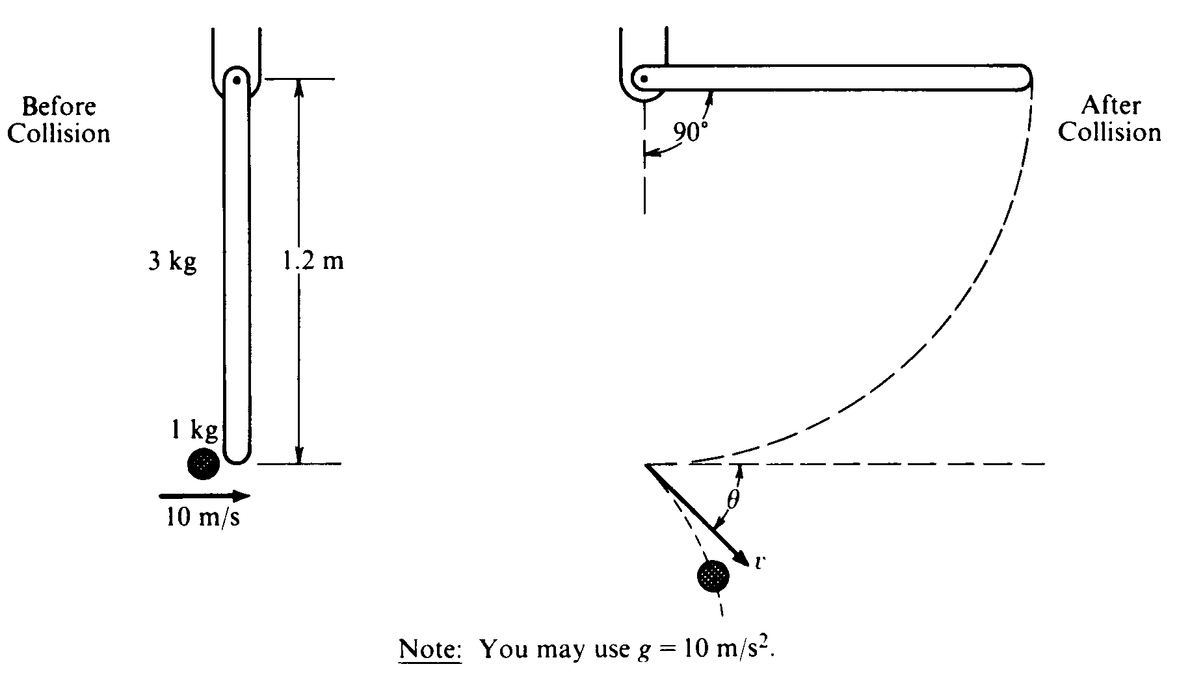
1987M3. A l.0-kilogram object is moving horizontally with a velocity of 10 meters per second, as shown above, when it makes a glancing collision with the lower end of a bar that was hanging vertically at rest before the collision. For the system consisting of the object and bar, linear momentum is not conserved in this collision, but kinetic energy is conserved. The bar, which has a length l of 1.2 meters and a mass m of 3.0 kilograms, is pivoted about the upper end. Immediately after the collision the object moves with speed v at an angle θ relative to its original direction. The bar swings freely, and after the collision reaches a maximum angle of 90° with respect to the vertical. The moment of inertia of the bar about the pivot is I_{bar} = ml²/3 Ignore all friction.
a. Determine the angular velocity of the bar immediately after the collision.
b. Determine the speed v of the l-kilogram object immediately after the collision.
c. Determine the magnitude of the angular momentum of the object about the pivot just before the collision.
d. Determine the angle θ.
1987E1. A total charge Q is distributed uniformly throughout a spherical volume of radius R. Let r denote the distance of a point from the center of the sphere of charge. Use Gauss's law to derive an expression for the magnitude of the electric field at a point
a. outside the sphere, r > R;
b. inside the sphere, r < R.
The electrostatic potential is assumed to be zero at an infinite distance from the sphere.
c. What is the potential at the surface of the sphere?
d. Determine the potential at the center of the sphere.
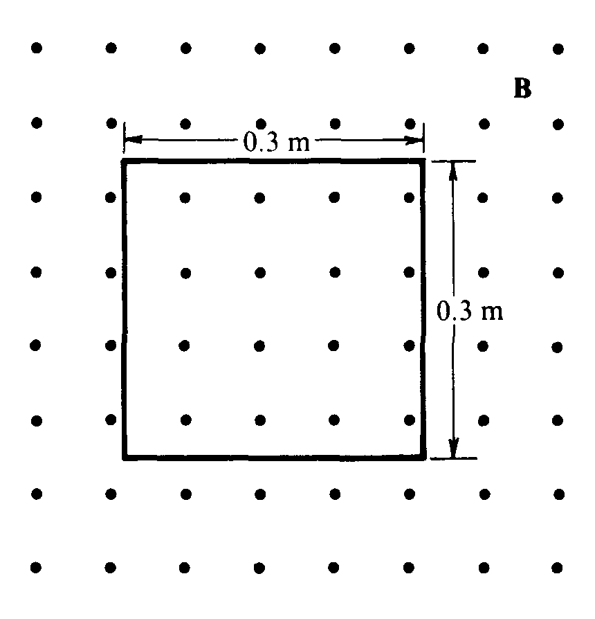
1987E2. A square wire loop of resistance 6 ohms and side of length 0.3 meter lies in the plane of the page, as shown above. The loop is in a magnetic field B that is directed out of the page. At time t = 0, the field has a strength of 2 teslas; it then decreases according to the equation B = 2e^{- 4t}, where B is in teslas and t is in seconds.
a. Determine an expression for the flux through the loop as a function of time t for t > 0.
b. On the diagram above, indicate the direction of the current induced in the loop for time t > 0.
c. Determine an expression for the current induced in the loop for time t > 0.
d. Determine the total energy dissipated as heat during the time from zero to infinity.

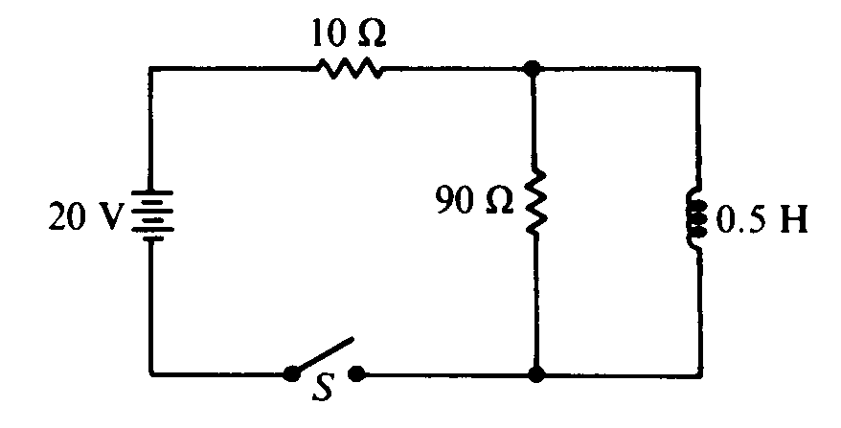
1987E3. In the circuit shown above, the switch S is initially open and all currents are zero. For the instant immediately after the switch is closed, determine each of the following.
a. The potential difference across the 90-ohm resistor
b. The rate of change of current in the inductor

The switch has remained closed for a long time. Determine each of the following.
c. The current in the inductor
d. The energy stored in the inductor

Later, at time t_{o}, the switch is reopened.
e. For the instant immediately after the switch is reopened, determine the potential difference across the 90-ohm resistor.
f. On the axes below. sketch a graph of the potential difference across the 90-ohm resistor for t > t_{o}.
